C211 Readings & Assignments: Week 3

Week 3 Reading
Complete the following reading early in the week:
- Week 3 online lectures
- From your course Textbook, Storyboards, Motion in Art, read the following chapter:
*Chapter 6: Benefits to Production
Week 3 Assignments Overview
Assignment Summary: Week 3 | Due Date
Assignment 1: Discussion Questions | Week 3, Day 2
Assignment 2: Storyboard Test | Week 3, Day 4
Assignment 3: Final Project: Target Market Exercise | Week 3, Day 5
Remember that all assignment details can be found on the assignment pages located throughout the week. Go to those specific pages for direction on how to complete each individual assignment.

Establishing the Objective
Welcome to the third week! This week will focus on two things: first, the importance of audience analysis and how to design for a specific audience, and second, the scenarios in which storyboards are generally developed. Let's start right away.

Who Is the Audience?
One of the first things to consider in the creative process is the audience. In everyday life, as we meet people for the first time we try to get a feel of the kind of people they are. What is their background? What is the most effective way to communicate with them so that they understand and respond? Finding answers to such questions, in a sense, is sizing up the audience. When creating a storyboard you should make an effort to do the same thing.
In the case of mass communication, the audience is called the target market. Until a target market is identified, you can't really start your work. For example if you need to promote a new medicine for treating cancer, you would never use humor in the promotion. A person suffering from the disease will not like your idea if it involves humor.

Learning Outcomes:
- Design for specific delivery methods
- Create a storyboard and render a short animated sequence
- Evaluate project constraints

This asprin commercial was taken off the air. Can you guess why?
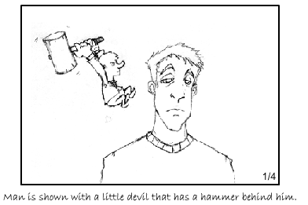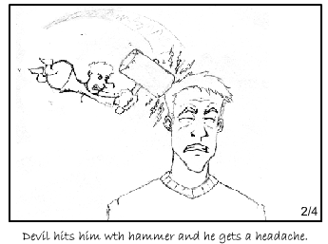
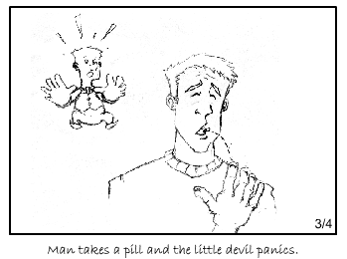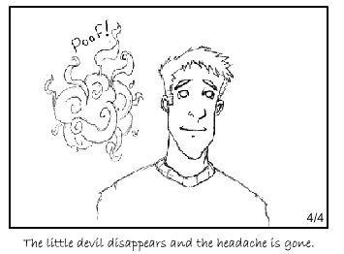
Although the commercial was well done and humorous, it seemed to be making fun of people with headaches. Obviously the commercial didn’t appeal to the target audience and had to be taken off the air. An audience analysis performed prior to production would have made the commercial a success.
Therefore as you set out to put your creativity to work, you should first identify the audience profile you are trying to reach. This may seem simple, but you will be surprised at the number of times a storyboard is rejected because the designer did not understand the target audience.

Knowing When to "Dumb it Down"
This industry term is not meant to insult anyone. What it refers to is dealing with the target audience in a way they will understand and follow. For instance, if you were writing copy for a target market identified as children aged five to ten, you would not include a lot of complicated words. When writing for an audience, stick to words that are both familiar and relevant to them.
Consider a situation where a manufacturer makes an outstanding product, yet does not go into a lot of engineering detail. Instead, he adopts a simple approach that will help his consumers remember the product name when they're in a store.

Budgetary Impact
A concept must also be realistic economically. A good practice is to test something small before you commit to something large. If you find that you have a great idea but it takes two hours to render one frame, it is wise to reconsider the path you are taking. For quite some time Pixar Films has been developing short films such as Geri's Game and For the Birds to include in their feature film releases. In addition to the incredible entertainment aspects, these shorts are also a testing ground for certain production techniques. In the case of Geri's Game and For the Birds, Pixar is trying to improve their capabilities for depicting skin tones, fabrics, and feathers.
Whenever you sell an idea, make certain it can be accomplished in production. In most cases you should have some sort of a guideline for a budget, especially if it is low. Always consider the financial aspect when creating a concept and make every effort to avoid problems.
View Geri’s Game from Pixar
http://www.pixar.com/shorts/gg/index.html

Meeting the Deadline
Budgetary issues often affect production time as well. If, for instance, you have to design an animated segment that requires rotoscoping a baboon playing an accordion, make sure there is enough time and money available for this plan. If not, a completely different concept may be in order. It is important for the storyboard artist to know if the action will be difficult and expensive to animate. A low-budget project requires low-budget planning.
Your ability to forecast production issues can help avoid serious scheduling problems. This is especially true when shooting exterior live action productions where the weather is the most prevailing factor. The good news is that animation is always predictable. It takes a certain number of frames per second to create convincing motion and the illusion of life. Still, a realistic deadline needs to be identified. In other words, a six-day schedule would be impossible to meet for an animated project because the production effort would take more than six days. A working knowledge of typical production turnaround time is essential to meeting deadline requirements.

Staying with the Message
It is possible to get so carried away with an idea, especially when comedy is involved that the main message of the project falls through the cracks. The main purpose of any assignment is to carry a message to the target audience. This is especially true when the project happens to be animated. Generally, live action is less wacky, but animators tend to "go over the top." When done right, animation is fun and entertaining, but it is worthless if the message is lost in the process.

Working in Various Scenarios
There are many companies involved in the entertainment and game art industry. Each has its own production methods. Storyboard artists working in this arena should understand how to work in each of these scenarios:
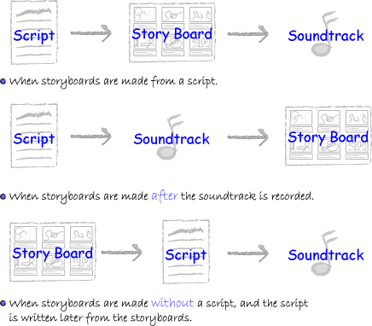
Let's look at each of these scenarios.

Working from a Script
There is a big difference in developing a storyboard from a script as opposed to developing a storyboard from a soundtrack recording. In prerecorded soundtracks, the emotions of an actor are easy to follow because of the actor's inflection and tone. But without a soundtrack, a script is merely a piece of paper with words written on it that can be interpreted in a number of ways. This can be illustrated through the following example:
"I didn't hit your horse."
It seems simple enough, but this five-word sentence can have four different connotations. The first is just as it reads above. Please look at the following versions with an emphasis on the word in bold.
- I didn’t hit your horse : you didn’t hit the persons horse, but someone else may have.
- I didn’t hit your horse: Implies you didn’t hit the horse but may have stabbed it. (?!)
- I didn’t hit your horse: Gives an impression you didn’t hit the persons horse but someone elses.
- I didn’t hit your horse: May mean you didn’t hit his horse but his dog.

Reading the Emotions
There are instances when a screenwriter does not always describe the emotion of the character because it seems apparent to the audience. A misinterpreted script can throw a scene off track. Similarly wrong interpretation of a character's emotional state can do irreparable harm to the scene. Read the following dialogue and try to interpret the reaction of the second character.
First character: "I sold the car for a thousand bucks."
Second character: "That's great!"
What is the emotional state of each character? The answer to that is that no one has any idea simply by reading the script. One thing is certain, however, acting should always display the emotional state of the character, but you need to be sure exactly what that state is. It can be anger, joy, sadness, frustration, fear or any other emotion, but is it correct?

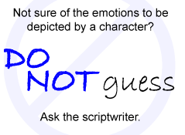
Do Not Guess!
It's always best to consult the scriptwriter than to interpret a script yourself. Once the intent/emotion of the character is clear to you, you can depict it in the storyboard. If you misinterpret the script, you will have to make changes to the boards later—a process that is frustrating, time-consuming, and in some cases expensive.

Working from a Soundtrack
Sometimes storyboards are made after the soundtrack for a script has been recorded. It is a good idea to be present when a soundtrack is being recorded because you have an opportunity to observe facial expressions and body language of the dubbing artists that you can incorporate into the visual rendition of the sequence.
Even if you are not present during the recording, the soundtrack greatly enhances your ability to depict proper emotions and connotations in the storyboards.
Once a soundtrack is laid down, it is important to adhere to it as closely as possible. Any deviation will require some sort of editing or modification in the soundtrack or the storyboard. You cannot arbitrarily change dialogue without involving another recording session.

Slugging the Track
In order to portray a scene accurately, you might find it necessary to hold a shot for a longer period than the soundtrack provides. This is a common practice because many times the recording session is only dealing with the words, not the pauses between two sentences. As an example, a character has to speak a line just after he hits the ground. The storyboard artists may feel the scene would be funnier if the fall took three seconds longer than the time allowed in the track. It is perfectly acceptable to delay the track for the extra time needed to pull the scene off more effectively. This does not create extra work or problems, provided there is enough time available in the sequence. However, if you were producing a 30-second television commercial, it would be impossible to add 3 seconds to a fixed-length soundtrack.

Adding Extra Sound Effects
The role of a storyboard artist is not just limited to the preproduction stage. Sometimes a storyboard artist asks for an extra sound effect to enhance the image on the screen during the postproduction stage. Recall that the preproduction phase involves making critical decisions and doing heavy planning crucial to the project, as well as creating the storyboards. The production phase involves creating actual scenes, be it animation, stop motion, or live action. The postproduction phase involves putting all the finished scenes together. It includes editing, audio sweetening, compositing, music score, etc.
Adding sound effects in the postproduction phase is a small effort that can really make a scene pop. The postproduction phase is the last chance to make the project as perfect as possible. But keep your expectations in line—the postproduction phase is no place to expect a miracle.

Timing to the track
When you are working from a script with a soundtrack, the words themselves establish when to change camera angles and shots. Starting out, most storyboard artists will look for strong "word cues" in the soundtrack and change shots accordingly. In other words, if the dialogue mentions a particular object, the story artist will cut to a close up of the object being mentioned. In time, the story artist may start to experiment and develop a style that is less obvious but more interesting.
Study the work of movies, television shows, and other productions that impress you. Discover some of the strategies directors use and try to apply them to what you are doing. This is not to say you are to copy other people's work, but studying proven techniques will expand your creative capacity. You must see the world around you in an exciting and interesting way, then be able to convey it as a visual image for all to see as well.

Developing Storyboards without a Script
At times storyboards are developed without a script and the script is written later from the storyboards. Of the three scenarios described this week, creating storyboards without a script, and later creating the script from the boards, allows you the most creative license. In many cases the script evolves from the story panels, which can be the best way to work. Using a bulletin board, pushpins, and 3" x 5" cards, you can work out the scenes and make quick changes as you see fit without having to go back through and change anything else that follows. This presents an excellent opportunity for input as you bounce off your ideas on others or have someone to collaborate with. Once you are satisfied with the scenes, you can create the final storyboards and then finalize the script that evolved from this process.

Summary
This week covered the various scenarios in which storyboards are developed - working from the script with or without a soundtrack and working without a script. We also discussed how to align storyboards with the objective of the project. Here it is appropriate to reiterate the importance of audience analysis in creative development. No matter how great the concept, no matter how unique the idea, no matter how well it is visually presented, it's all worthless if it does not reach the intended audience and deliver the correct message. Missing either of these two objectives means you've missed your target.

Assignment 1: Discussion Questions
By Week 3, Day 2, respond to the discussion questions assigned to you by the facilitator. Submit your responses to the appropriate Discussion Area. Start reviewing and responding to your classmates as early in the week as possible. Be clear and concise in your comments.
Assignment 1 Grading Criteria and Respective Point Value | Maximum Points
Response Criteria
Met the criteria for the correct responses to the questions assigned | 4
Used vocabulary relevant to the current week's topics - at least four terms | 4
Participation Criteria
Used vocabulary relevant to the current week's topics - at least four terms | 4
Participated in the discussion by asking a question, providing a statement of clarification, providing a point of view with rationale, challenging a point of discussion, or making a relationship between one or more points of the discussion | 4
Justified ideas and responses by using appropriate examples and references from texts, Web sites, and other references or personal experience | 4
Total: | 20
For assistance with any problems you may have when completing this assignment—OR—to offer your assistance to classmates, please use the Problems and Solutions Discussion area located through the left side navigation link.
Please, respond to two (2) questions provided. Thank you, Andrzej
DQ 1: A company wants to use a global campaign to launch a drug that clears nasal congestion. For this you have been assigned to create a television commercial. Develop a concept that is appropriate for this campaign and share it with the class. Include your reasons in the response.
DQ 2: You are developing a storyboard for a 10-minute documentary that will depict the ill-effects of smoking in teenagers. How will you ensure that the storyboard treatment is aligned with the target audience? Give reasons.
DQ3:You are working as a storyboard artist in a studio that is producing a 50-episode animated television series. The series is about a young detective who solves his cases in an unconventional manner. However inspite of a gripping storyline, the series is not well received by the audience. A survey conducted to detect the problem shows that the audience finds the serial dull and boring. How would you change the treatment of the storyboards so that it aligns with the storyline?
DQ4: You learned about storyboarding from a sound track, storyboarding from a script, and storyboarding without a script. Think of situations where each of these methods would be applicable. Why would you use a particular method in that situation?
DQ5: Animation studios usually define some standards to establish a "style and look" for a particular production. Sometimes this implies violating a few design principles. A storyboard artist has to adapt to this style in their work. Does this hamper creativity or enhance it? Give reasons to support your viewpoint.

Assignment 2: Storyboard Test
Download the storyboard test files from the Doc Sharing area of the course. The titles of all these files are prefixed with "Week 3 SB test."
After downloading, review the instructions given in C211_W3_SBtest_Instructions.doc carefully because there will be no other direction beyond those included in this file. Pay particular attention to StoryboardArtist_Review_sheet.doc to ascertain what you will be graded on.
Prepare thumbnail storyboards of the entire sequence. Then, using the blank panels from the file, panels.zip prepare four pages of rough storyboards from any sequential segment in your thumbnails. Next select one of the four rough pages and trace one page to prepare for final clean-up.
By Week 3, Day 4, scan and post all the deliverables as specified in C211_W3_SBtest_Instructions.doc file to the W3: Assignment 2 Discussion Thread. Review and critique at least two other student's submission by the end of the week using StoryboardArtist_Review_sheet.doc as a template.
Assignment 2 Grading Criteria and Respective Point Value  Note: Refer to the Storyboard_Review_sheet.doc for the details of each criterion. | Maximum Points
Working Habits | 8
Art | 14
Filmmaking | 12
Animation | 10
Valid and meaningful comments to at least two students. | 4
Total: | 48
For assistance with any problems you may have when completing this assignment—OR—to offer your assistance to classmates, please use the Problems and Solutions Discussion area located through the left side navigation link.
, Please read carefully all of the instructions. You will be preparing your storyboards based on the character information and script provided. This assignment is similar to what would be expected of a applicant for a story board position at a studio.
Best of luck and have fun. Andrzej

Assignment 3: Final Project: Target Market Exercise
Make up a fictional company that provides merchandise or services. The company should be large enough to sponsor a regional or national marketing campaign. Imagine a product/service offered by this company and identify the target audience, such as middle-aged housewives, children, young adults, etc.
Suggest a style or approach that would appeal to this target audience.You may establish demographics of the target market by age, gender, and general location to determine the style/approach. Based on the style/approach, devise a plan for a storyboard as part of an ad campaign for this company. By Week 3, Day 5, submit the description of the company, target audience, style/approach, and the storyboard plan to the appropriate Discussion Area.
Review and critique the work of at least two other students as early as possible and incorporate the changes based on the discussions during the week. Resubmit the modified documents to the W3: Assignment 3 Dropbox by the end of the week.
Assignment 3 Grading Criteria and Respective Point Value | Maximum Points
Created a fictional company that is large enough to sponsor a regional or national marketing campaign | 4
Identified the appropriate target audience for the product/service | 4
Suggested an effective style or approach for the target audience | 4
Established a plan to communicate with this audience | 4
Reviewed and commented on at least two other student's submissions, and incorporated the changes based on the discussions | (2 x 2 for each)
Total: | 20
For assistance with any problems you may have when completing this assignment—OR—to offer your assistance to classmates, please use the Problems and Solutions Discussion area located through the left side navigation link.
Please post your assignment here describing your company and required ad campaign storyboard. Make comments to others as instructed. Thanks, Andrzej

